|  |
| --- |
| Name: N.D. Manula Sajina Narasingha |
| Student Reference Number: 10707288 |



|  |  |  |
| --- | --- | --- |
| Module Code: SOFT255SL | Module Name: Software Engineering for the Internet using JAVA | |
| Coursework Title: Library Management System | | |
| Deadline Date:  01/12/2020 | | Member of staff responsible for coursework:  Ms. Sulari Fernando |
| Programme:  Bsc (HONS) Software Engineering | | |
| Please note that University Academic Regulations are available under Rules and Regulations on the University website [www.plymouth.ac.uk/studenthandbook](http://www.plymouth.ac.uk/studenthandbook). | | |
| Group work: please list all names of all participants formally associated with this work and state whether the work was undertaken alone or as part of a team. Please note you may be required to identify individual responsibility for component parts.  N.N.M.S. Narasingha - 10707288  M.R.T. Fernando - 10707199  N.N.D.G. Liyanage - 10707288  P.Y.S.D.S. Manawadu - 10707274  L.A.L. Fernando - 10025597  ***We confirm that we have read and understood the Plymouth University regulations relating to Assessment Offences and that we are aware of the possible penalties for any breach of these regulations. We confirm that this is the independent work of the group.***    Signed on behalf of the group: | | |
| Individual assignment: ***I confirm that I have read and understood the Plymouth University regulations relating to Assessment Offences and that I am aware of the possible penalties for any breach of these regulations. I confirm that this is my own independent work.***  Signed : | | |
| Use of translation software: failure to declare that translation software or a similar writing aid has been used will be treated as an assessment offence.  I *have used/not used translation software.  If used, please state name of software………………………………………………………………… | | |
| **Overall mark _____% Assessors Initials ______ Date_________** | | |

*Please delete as appropriateSci/ps/d:/students/cwkfrontcover/2013/14



**SOFT255SL - Software Engineering for the Internet using Java**

***Coursework 2020–2021***

Introduction of Project

The project we created is the library management system for NSBM GREEN UNIVERSITY. The library management system can be introduced as a library management software for controlling the transaction in a library. The project library management system is developed in java, which nearly focus on basic operations in a library like adding new member, new books and updating new information, searching books and members and facility to borrow and return books.

This library management system project is very simple and can be used by both beginners and advanced users. The library business framework, which offers a wide range of adaptable and useful highlights, allows bookkeepers and library clients to maximize time and productivity. The library system provides specific data on insights, staff, and books. It will follow the number of books that can be accessed in the library and the number of books given to undergraduates. All system access are include with University ID number. If someone insert wrong ID number they can't access system. Who have registered in university, only they can use this system.

Definition of the Problem

The Library is very important for the daily learning activities of the students. Due to the lack of online facilities for our university library system, students have to face severe difficulties. However, at present the number of students joining the library is increasing day by day. Therefore, students have to wait in the library for a long time to receive or hand over a book. Using the latest technology, students will be able to connect with the library in online.

Project Objectives

This Project principle target of the application is to robotize online the current arrangement of physically keeping up the records of the exchange that occurs in the framework. The targets that will be accomplished after consummation of this venture are talked about in this subchapter. The points and goals are as per the following:

* Profoundly Secure, Scalable and Reliable; University libraries profit by adaptable foundation, job based secure access, superior and dependable to guarantee consistent admittance to library information base.
* Mobile Access; The library the board framework gives versatile admittance to look through the library list, timetables, books and assets from anyplace, at some random time by means of cell phones and tablets.
* The objective of the library management system is to handle the entire activity of a library.
* Request column for librarian for providing new books.
* The software keeps track of all the information about the books and their complete details.
* Student login page where student can find books issued by him/her and date of return.
* A search column to search availability of books.
* The system contains database where all the information will be stored safely.

Architecture of the Project

ER Diagram

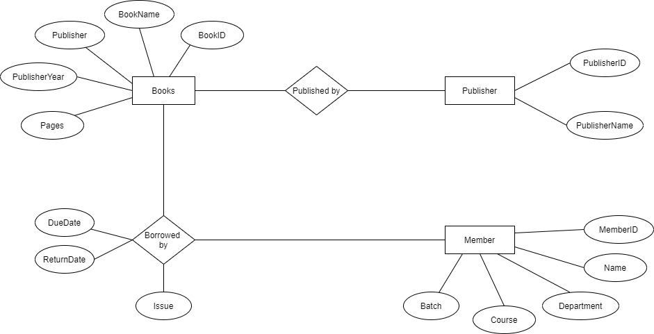

Use case Diagram

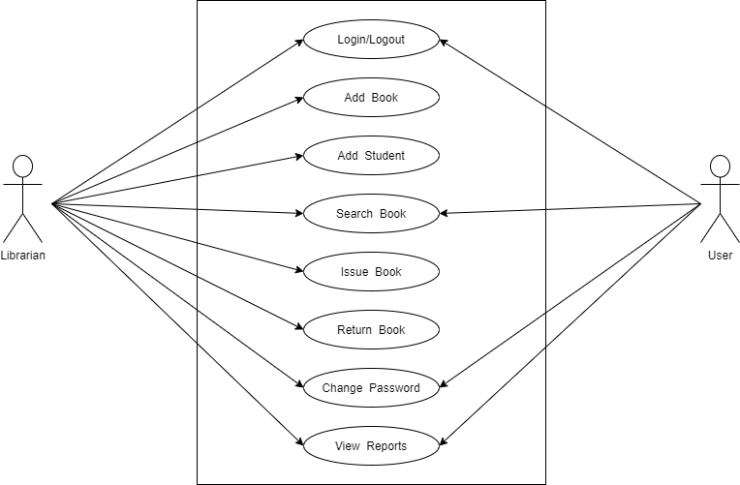

Class Diagram

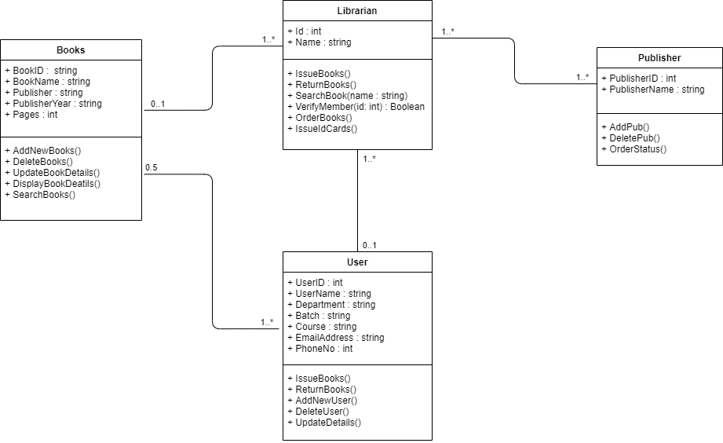

Network Diagram

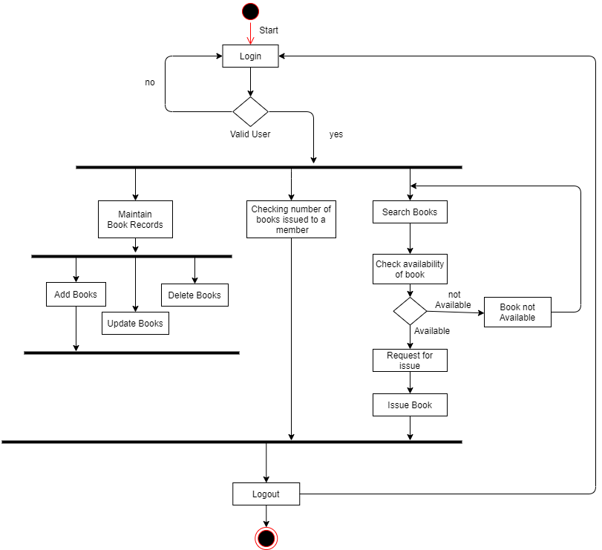

Architecture Diagram

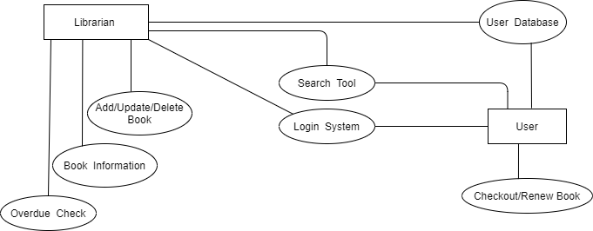

Hardware Requirements

|  |  |
| --- | --- |
| **HARDWARE** | **DESCIPTION** |
| RAM | 4GB |
| Hard DISK | 1TB |
| CD ROM | 512MB |
| Processor | Pentium® Dual-core CPU |
| Monitor | Any |
| Keyboard | 122Keys |

Software Requirements

|  |  |
| --- | --- |
| **SOFTWARE** | **DESCRIPTION** |
| Operating System | Windows 10 |
| Programming Language | Java |
| Front End | NetBeans 8.2 |
| Back End | My SQL Sever |

Project Methodology

We have used good methodology for develop this system. It can be defined as a waterfall model. The waterfall model is a part of System development life cycle model (SDLC). Before we started creating this system, we thoroughly analysed all the information needed to create the system design. During the design phase, the data, interface, database, and complete system layout related to this system are created. Our system is always updated with the latest technology, so users can easily use it and have a fresh experience with the latest technology. Users may encounter various problems while using this system. In some cases, there may be errors in this system.

In such cases, we use the latest technology to find solutions. Modern technology can be used so that people who use this system can use it very easily

The project created with Java used for controlling and monitoring operations in the library management system has been divided into five main modules:

* Database module: This has two functions – Insertion of data and extraction of data with a user-friendly screen.
* Report module: For the borrowed books list to display.
* Available module: To view the availability of books.
* Search Module: search facility for books and members.
* Payment module: Payment facility for fine payments.

User Interfaces

Start Page

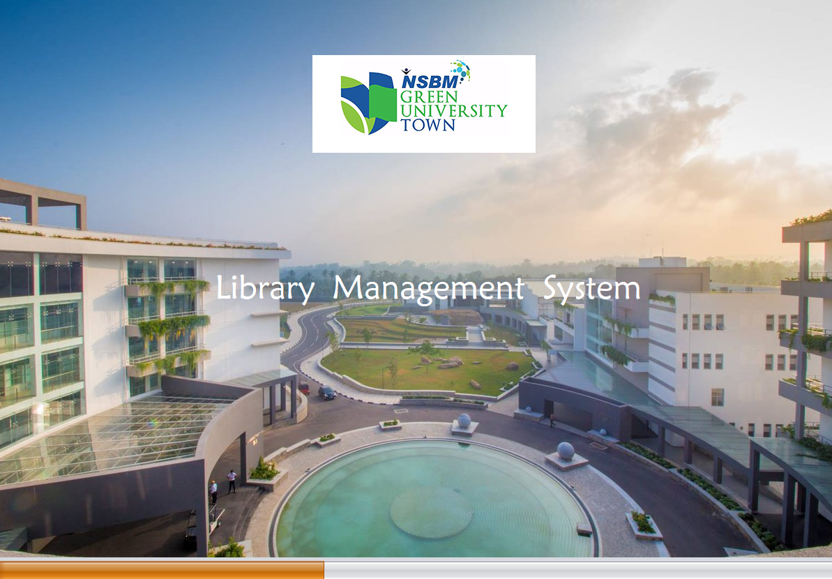

Login Page

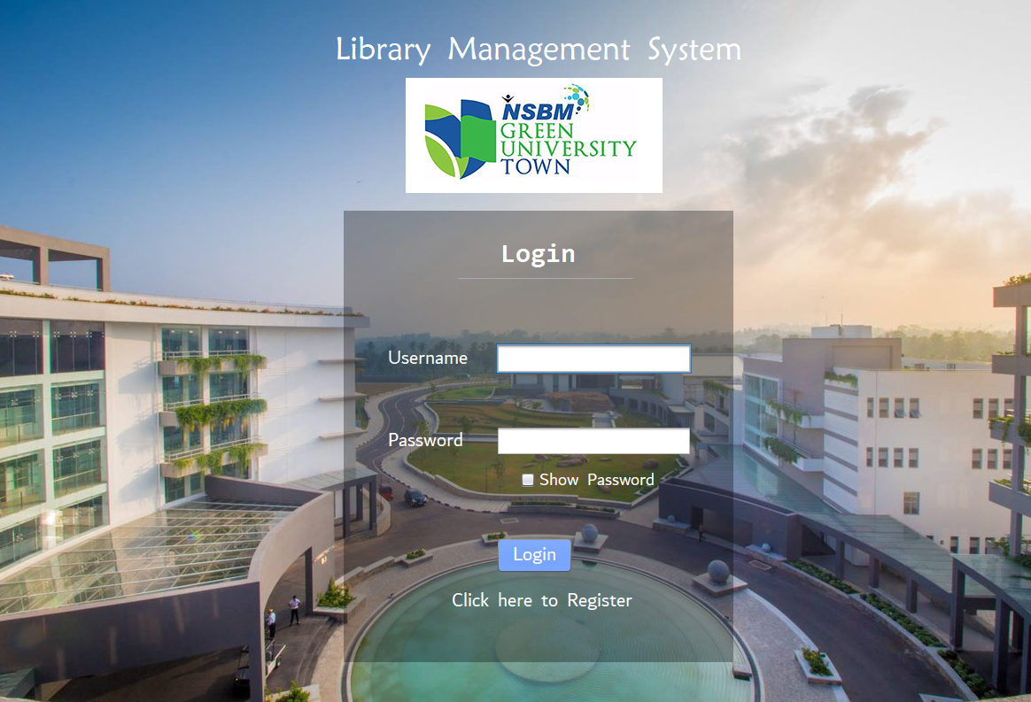

Register Page

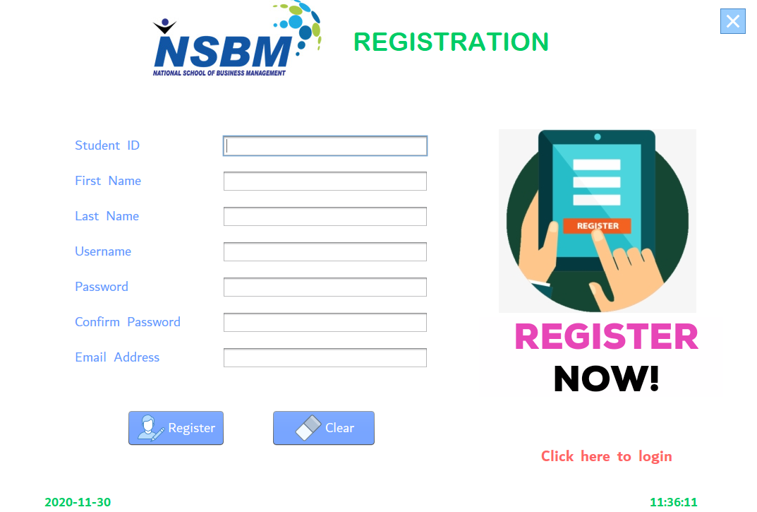

Home Page

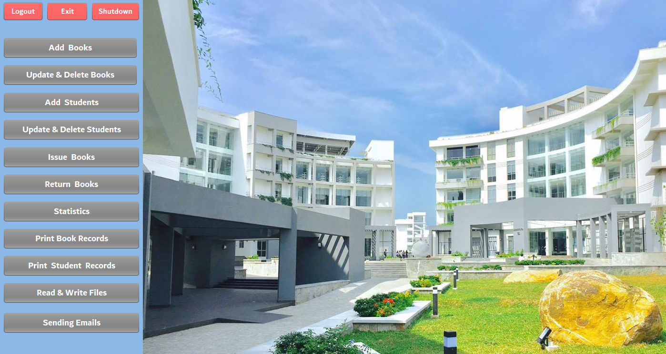

Add Books Page

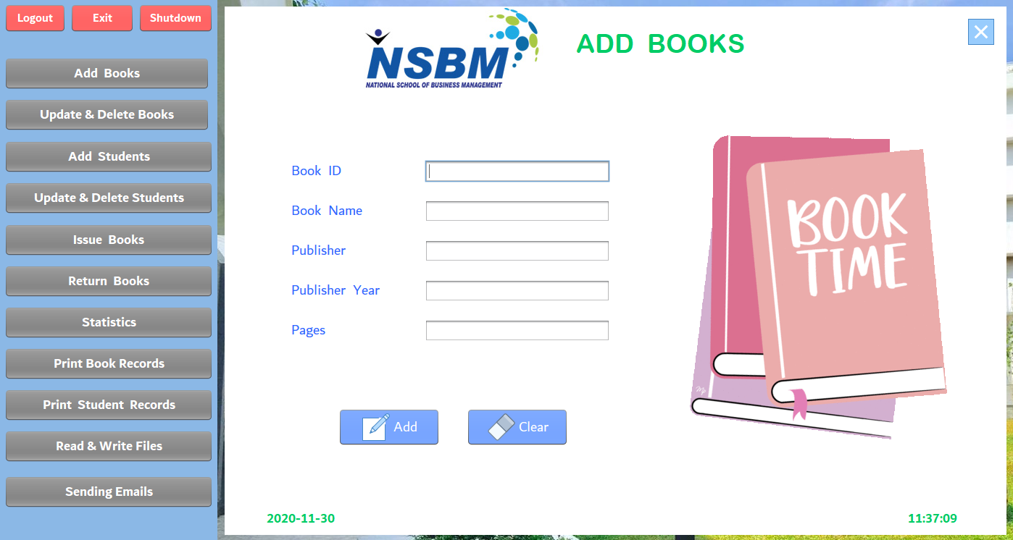

Update & Delete Books Page

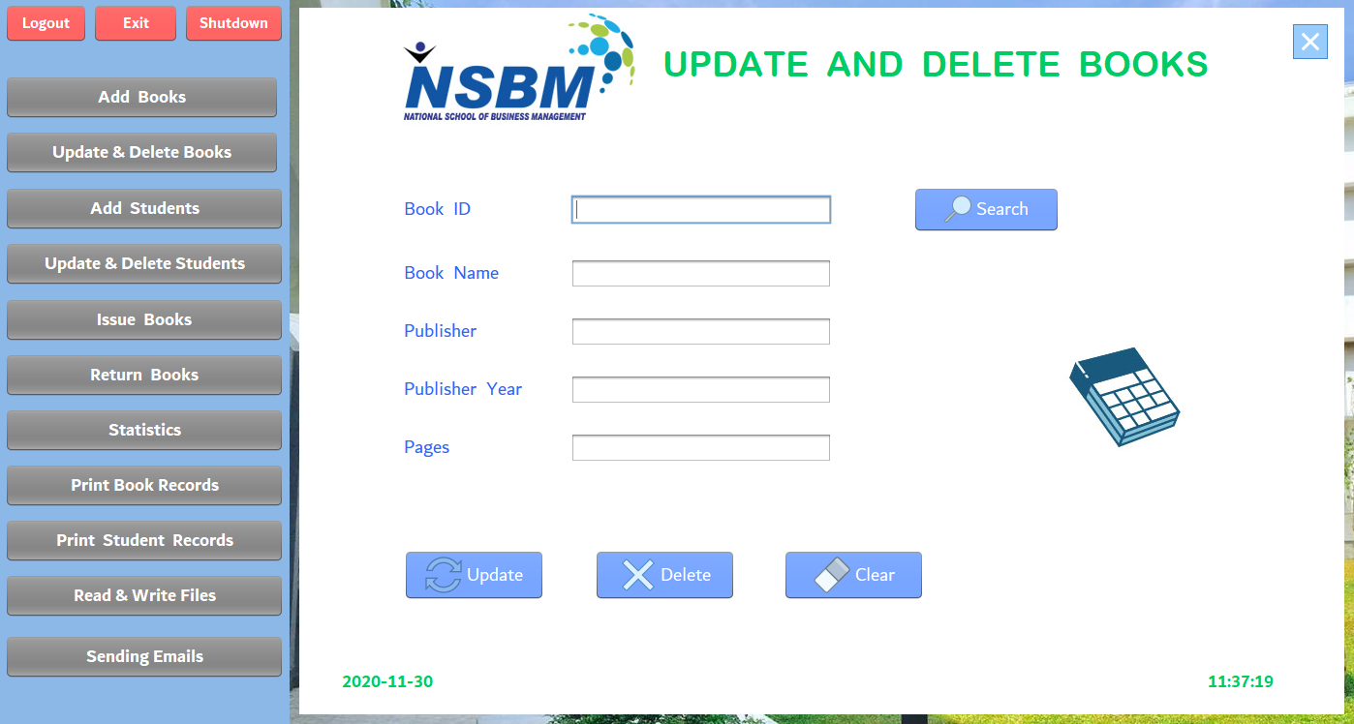

Add Students

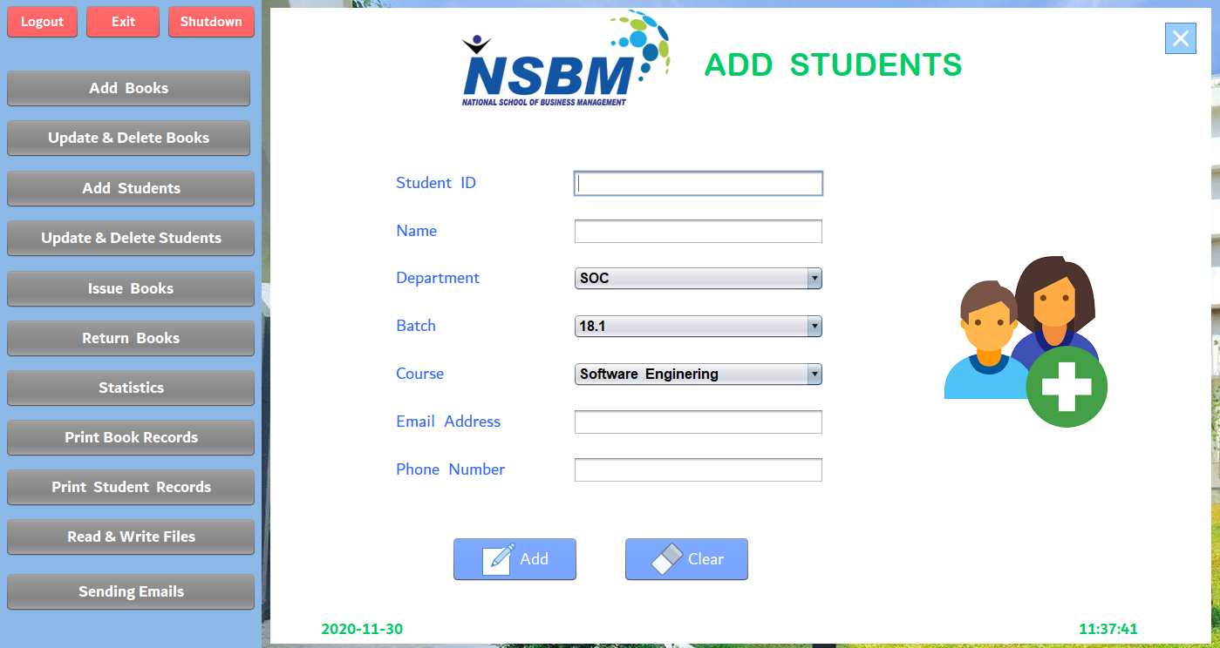

Update & Delete Students

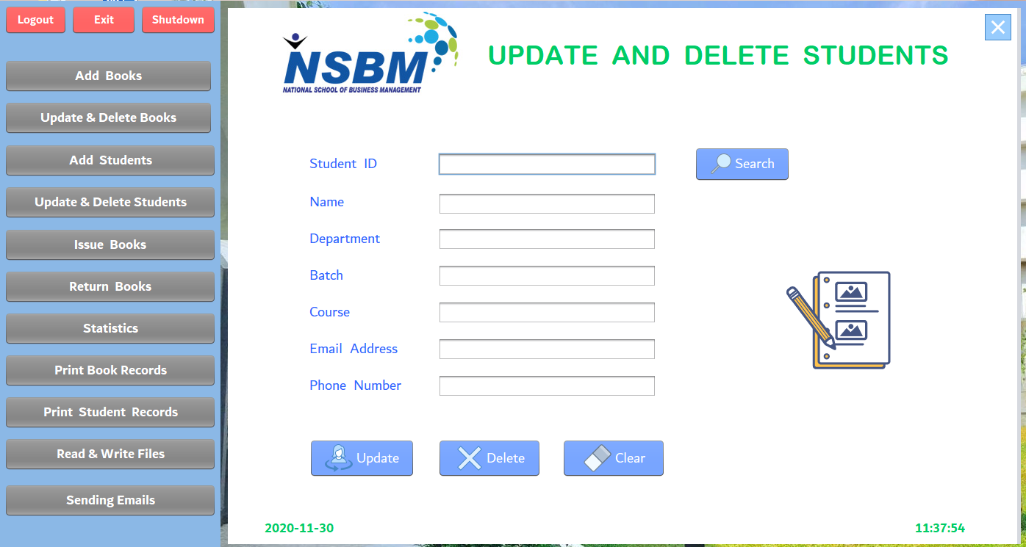

Issue Books

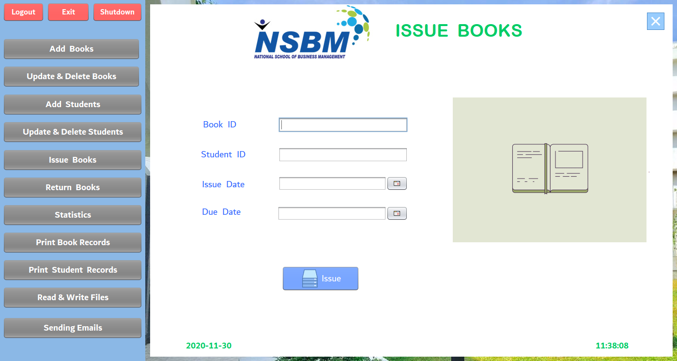

Return Books

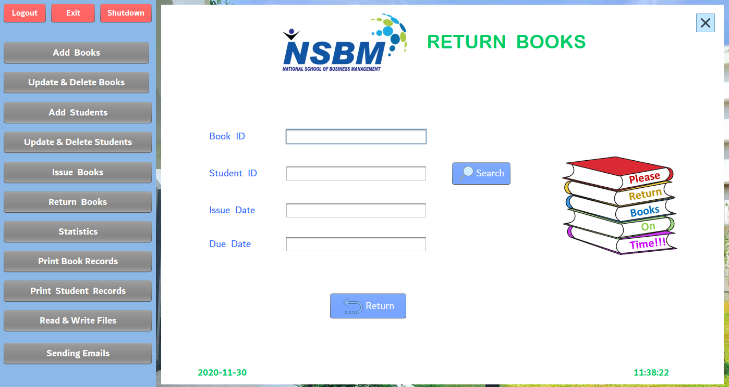

Statistics

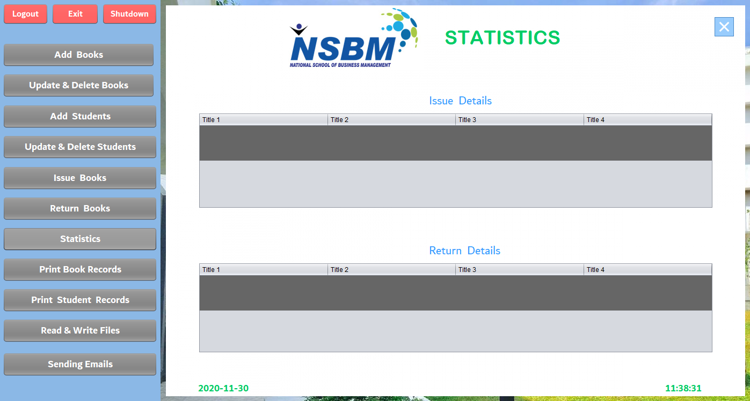

Print Book Records

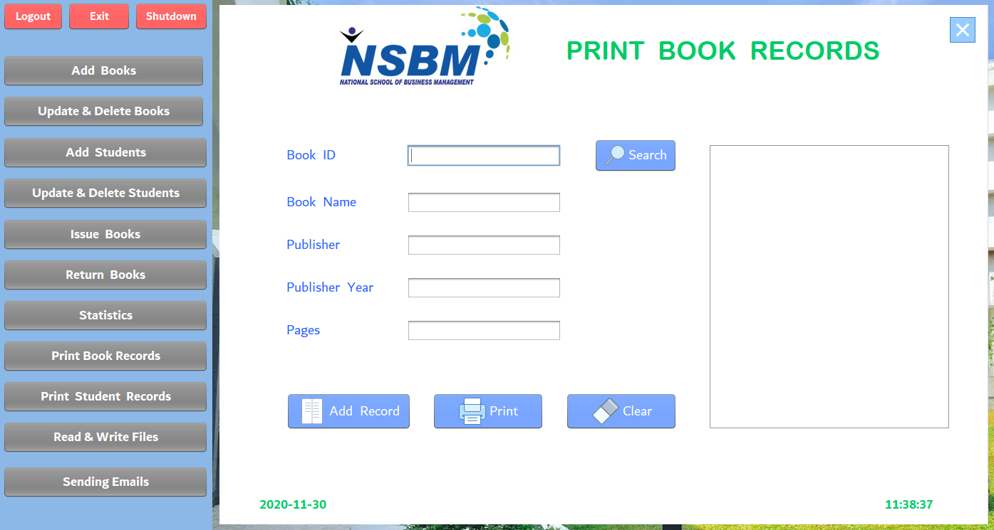

Print Student Records

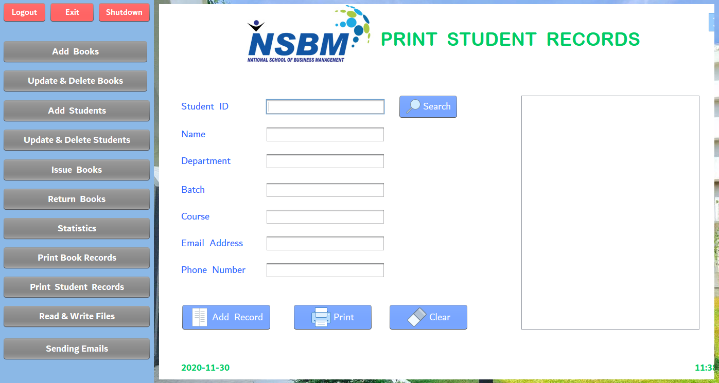

Write & Read Files

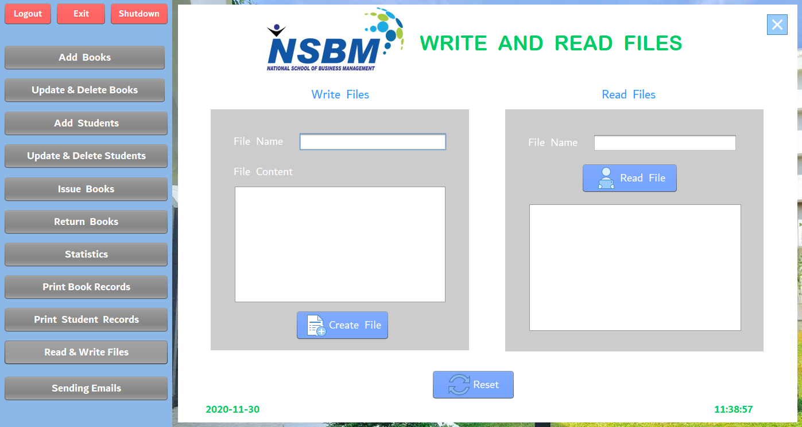

Sending Emails

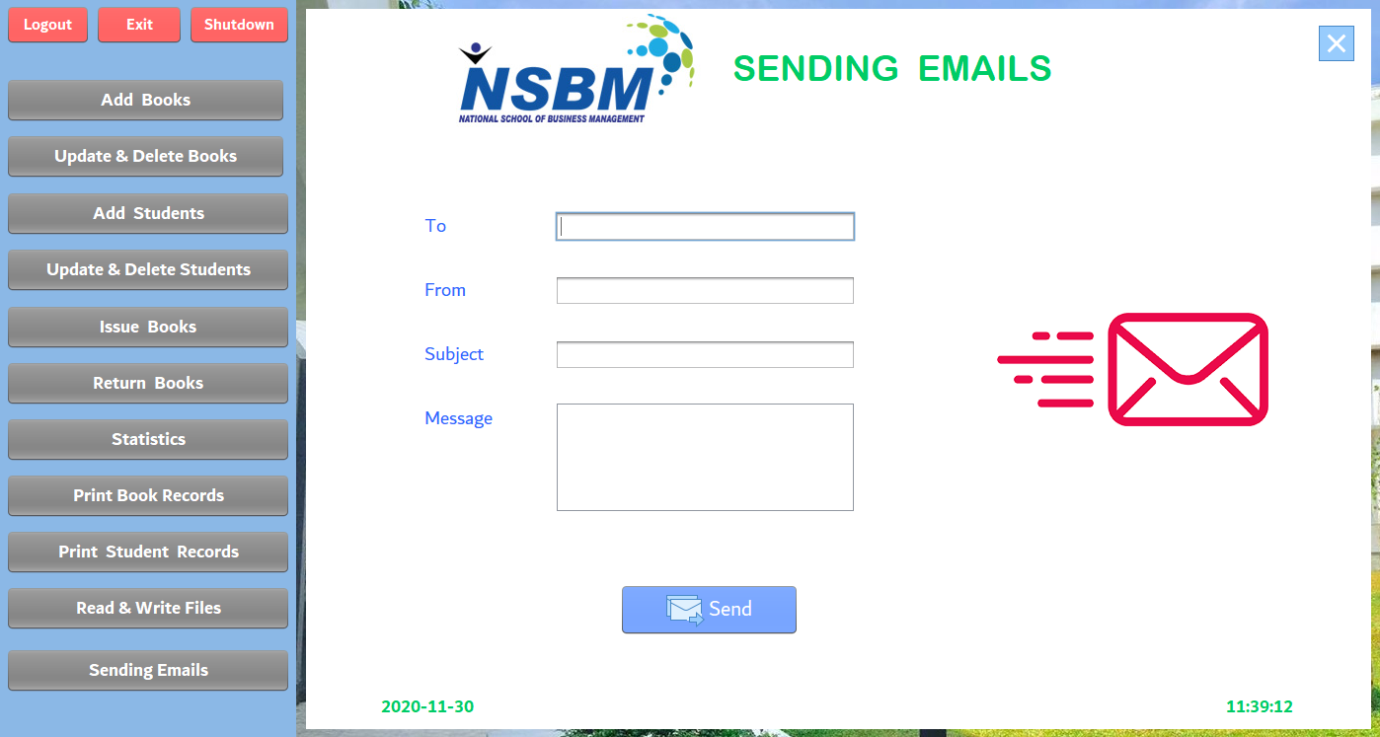

Workload Matrix

|  |  |  |  |  |  |
| --- | --- | --- | --- | --- | --- |
| Student Id | 10707288 | 10707199 | 10707256 | 10707274 |  |
| Start page |  |  |  |  | **\*** |
| Login page |  |  |  |  | **\*** |
| Register page |  |  |  |  | * |
| Home page |  | **\*** |  |  |  |
| Add Books page |  | **\*** |  |  |  |
| Update and Delete Book page |  | **\*** |  |  |  |
| Add students |  |  |  | **\*** |  |
| Update and delete student |  |  |  | **\*** |  |
| Issue Book |  |  |  | **\*** |  |
| Return Book | **\*** |  |  |  |  |
| Statistic | **\*** |  |  |  |  |
| Print Book Records | **\*** |  |  |  |  |
| Print student Record |  |  | **\*** |  |  |
| Write and Read files |  |  | **\*** |  |  |
| Sending Email |  |  | * |  |  |